Morning Routine
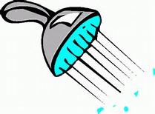
Before leaving for school there are a lot of things to think about.
Things to think about in your morning routine
- Check you have your homework
- Check you have the correct money
- Say “Goodbye”
- Pick up bag
- Leave for school

- Wake up
- Wash/shower
- Clean your teeth
- Get dressed
- Eat your breakfast
- Check your timetable
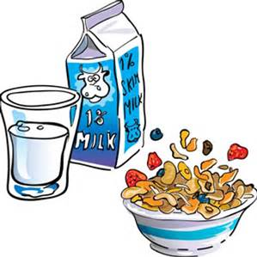
- Pack bag
- Check bag

Any others?
- ___________________________
- ___________________________
- ___________________________
Plan your morning routines with approximate time


You may be able to do some preparation (e.g. pack your bag) the night before.

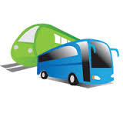
Planning Your Journey

It is important to plan your journey so that you can get to school on time.
Use a bus or train timetable to plan your journey.
Questions to ask | Answers
What written materials do I need? e.g. timetable
Where am I going?
Where is the nearest bus stop?
Where is the nearest train station?
How long will it take me to get to the bus stop/train station?
When do I want to arrive?
How long will the journey take?
Which bus/train will get me there on time?

What time do I want to leave my house?

Can I get a discount with a student card?
Can I get a travel card for a week or a month’s journey?
How much will the journey cost?

Getting to School
Your new school may be further away from where you live and it’s important to plan and practice your new journey to school ready for September.

How will I get to school? ______________________________

Do I know the way?
Will I have a friend to walk or cycle with?
Where can I leave my bike?
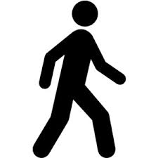
If you will be walking or cycling, you may need to think about the following questions and discuss them with an adult.

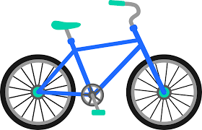

You might go by car sometimes, if you do then answer these questions

Will I go by car every day? | 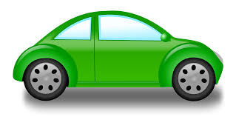
Who will drive me?
Will I get a lift home as well?

You might go by bus or train sometimes. If you do then answer these questions
Where is the bus stop or train station?
What time is my bus/train to school?
What number is the bus?
Will I need money for the fare?
What time is my bus/train from school?

Answer these questions whether you will walk, cycle go by car, bus or train.
How long will my journey take?
What time must I leave home?
What time will I get home?

School Equipment
Things I need to bring every day
Every day you will need your writing equipment. Circle the equipment you need in your pencil case. Draw in anything else you need daily.

Day | Things I will need to bring
Monday
Tuesday
Wednesday
Thursday
Friday
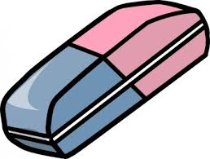
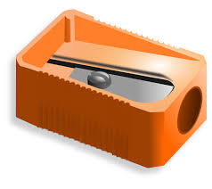
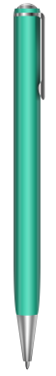
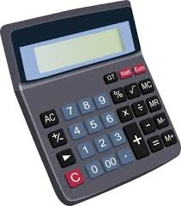
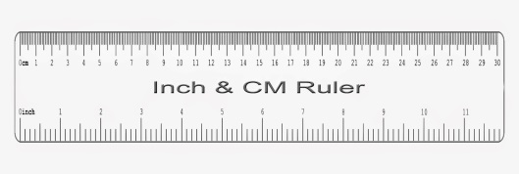

Some days you will need extra equipment. This will depend on the lessons you have that day. Look at your timetable and work out the additional equipment you need each day.

Homework Schedule

Example
Name: Form:
Homework Schedule
Day: Monday

Subject | Time | Completed
Maths | 20 minutes | /
English | 20 minutes | /
French | 20 minutes | /

Name: Form:
Homework Schedule
Day:
Subject | Time | Completed

Taking Care of Yourself - Top Tips
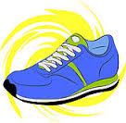
Keeping Fit
Exercise produces brain chemicals called endorphins that make people feel happy and improves energy levels. Regular exercise often makes people feel more energetic, allowing them to be more active, and reducing the likelihood of feel tired during the day. Most people report that they feel calm and have a sense of well-being after they exercise. Exercise also helps people sleep better.
Ideas
- Walk or bike to school if you live nearby and can safely do so.
- Between classes stand up and walk around, even if your next subject is in the same room.
- Stay active after school by joining a sports club or dance team or go for a walk.
Healthy Diet

- Eat breakfast - Eating breakfast, even if it’s just a banana and a glass of milk, kick-starts the body and makes it easier to maintain lasting energy throughout the day.
- Choose healthier snacks – Healthy snacks between meals are a great way to stay energised, and they keep your brain and body healthy and functioning.
- Water- Drink plenty of water throughout the day and try to avoid fizzy drinks.
Sleep
Go to bed at a regular time every night to recharge your body and mind. Be sure to turn off your phone, TV, and other devices when you go to bed. The recommended amount of sleep for young people your age is between 8 and 10 hours per night.
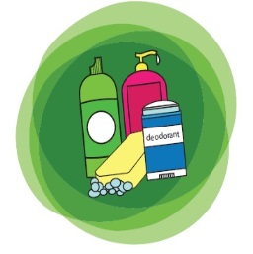
Keeping Clean
- Shower or bath and wash your hair regularly, probably at least 3 – 4 times a week. This can depend on how greasy your hair gets.
- Clean your teeth at least every morning and night.
- Use deodorant after washing.
- Change your underwear every day.
Appearance
It is important that we take care of our appearance.
- Brush your hair every day
- Make sure your uniform is clean
- Look in the mirror to check you are tidy every day before you leave home.
- Clean your shoes regularly

Money Management
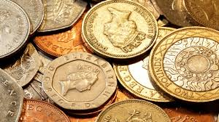
Now that you are at High School you will be responsible for managing your money on a daily and weekly basis.

The amount of money I have each week is £__.__
Some of this money needs to be spent on a daily basis.
Items to be bought | Monday | Tuesday | Wednesday | Thursday | Friday | Total
Snack
Lunch
Travel Expenses
Daily Total
Weekly Total |  |  |  |  |  | £
In addition to the money spent on a daily basis, some money will need to be saved each week in order to buy bigger items.

Items | Cost
Books
Stationary
Clothes
Footwear
Total Cost | £

